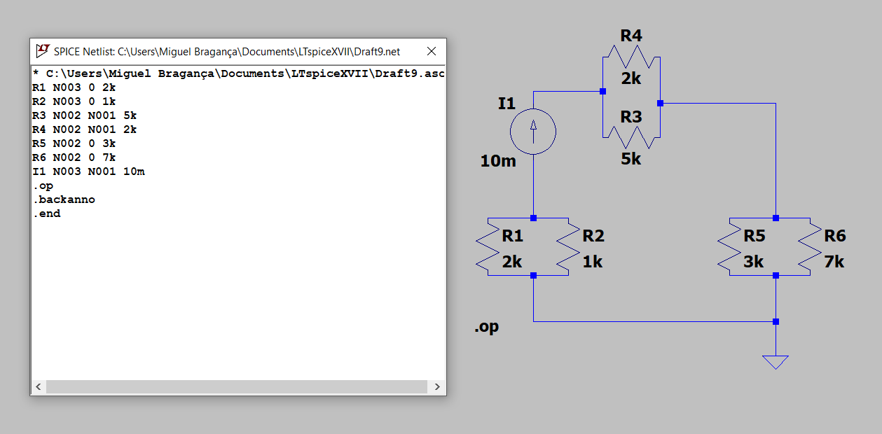

**R1 N003 0 2k**

**R2 N003 0 1k**

**R3 N002 N001 5k**

**R4 N002 N001 2k**

**R5 N002 0 3k**

**R6 N002 0 7k**

**I1 N003 N001 10m**

**.op**

**.backanno**

**.end**

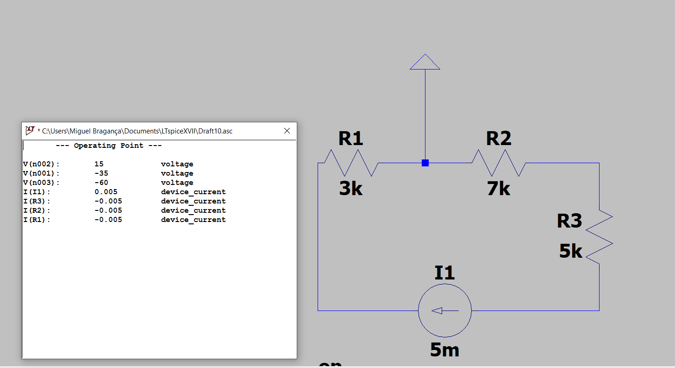

**R1 0 N002 3k**

**R2 N001 0 7k**

**R3 N003 N001 5k**

**I1 N003 N002 5m**

**.op**

**.backanno**

**.end**

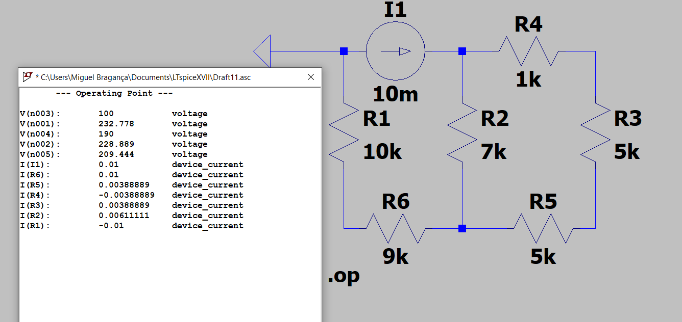

**R1 0 N003 10k**

**R2 N001 N004 7k**

**R3 N002 N005 5k**

**I1 0 N001 10m**

**R4 N002 N001 1k**

**R5 N005 N004 5k**

**R6 N004 N003 9k**

**.op**

**.backanno**

**.end**

**R2 N001 N004 7k**

**R3 N002 N005 5k**

**I1 0 N001 10m**

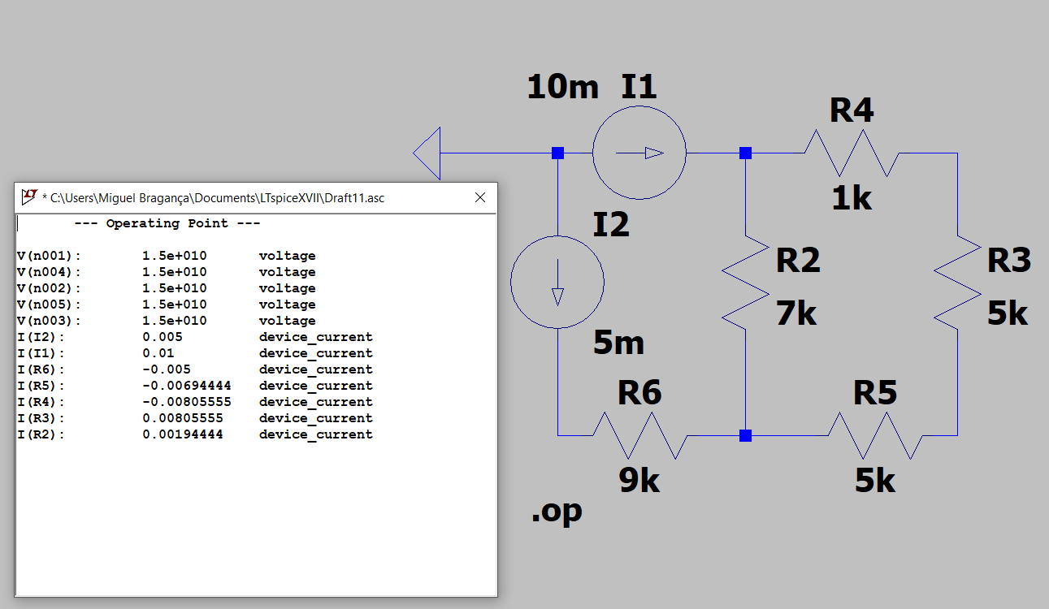**R4 N002 N001 1k**

**R5 N005 N004 5k**

**R6 N004 N003 9k**

**I2 0 N003 5m**

**.op**

**.backanno**

**.end**